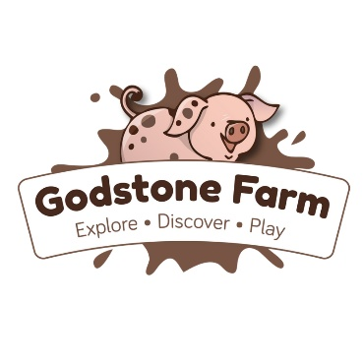

Party & Private Hire Add on Items

Hot or cold picnic box | £5.25 each
Party bags | £4.25 each
Ice-cream tub | £2.25 each
Ice lolly | £2 each
Animal feed | £0.80 each
Animal mask | £1 each
Tractor ride | £1.20 each
Additional adult entry | £7.74 each
Private Wiglet’s Play Village session 10am — 11 am | £165

